**EXPERIMENT – 6**

**TITLE: Package**

1. **Write a Java program to implement the concept of importing classes from user defined package and created packages.**

**(driver program)**

import user.myclass;

class show{

public static void main(String args[]){

myclass d1 =new myclass();

d1.demo();

}

}

**(package)**

package user;

public class myclass{

void demo(){

System.out.println("pakage implemented sucessfully!");

}

}

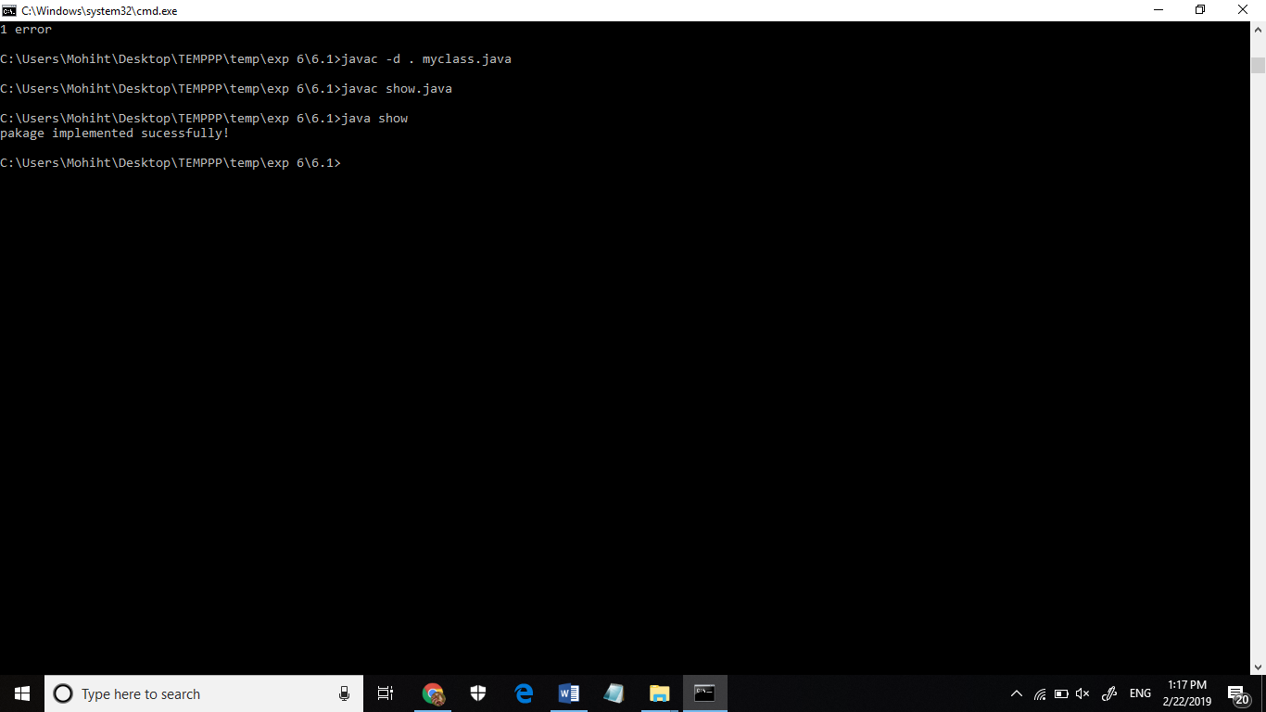

1. **Write a program to make a package Balance. This has an Account class with Display_Balance method. Import Balance package in another program to access Display_Balance method of Account class.**

**(package)**

package Balance;

class Account{

Display_Balance

{System.out.print("Balance is 100");

}

}

**(driver program)**

import Balance. Account;

class test{

public static void main(String args[]){

Account a1= new Account();

a1.Display_Balance();

}

}

